Studio 3

Name and Student Id: Xin Xu 30421225

Self-Evaluation:

|  |  |  |  |  |  |
| --- | --- | --- | --- | --- | --- |
| Need Help | Work in Progress | Pass | Credit | Distinction | ***High Distinction*** |

Tutor Evaluation:

|  |  |  |  |  |  |
| --- | --- | --- | --- | --- | --- |
| Incomplete | Needs improvement | Pass | Credit | Distinction | High Distinction |

Task 3.1:

{Answers}

I have done this task

{Screenshots}

A. screenshot of “Step 9”

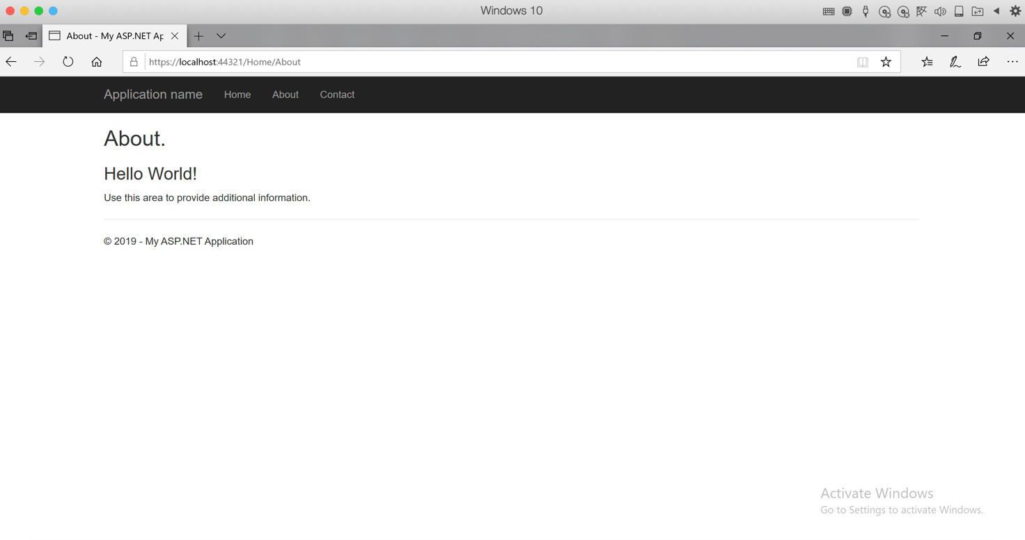

{Link to code repository}

{References}

{URLs}

https://drive.google.com/drive/u/1/folders/1EJm0eM0xhxAZXouHovffv0YsfZgxz1be

Task 3.2:

{Answers}

GitHub username: xxuu0040

{Screenshots}

GitHub

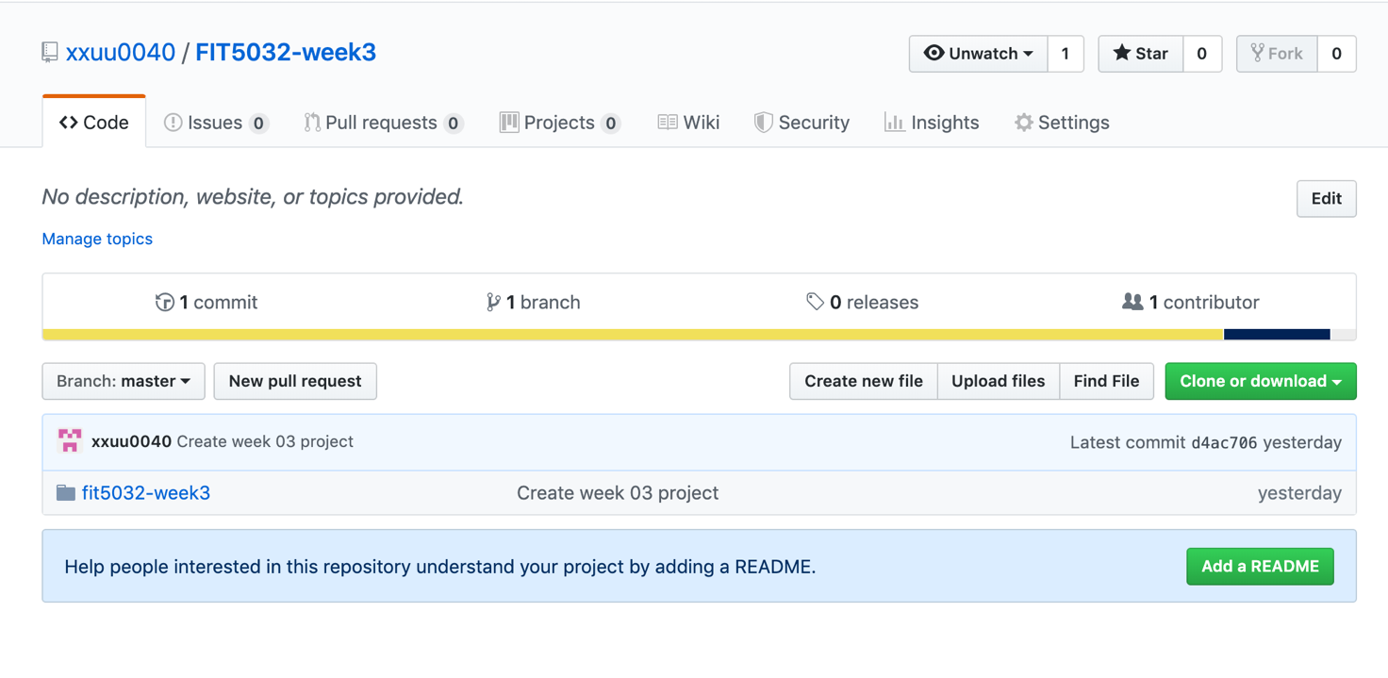

{Link to code repository}

<https://github.com/xxuu0040/FIT5032-week3/tree/master/fit5032-week3>

{References}

{URLs}